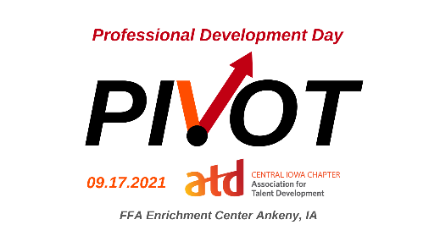
Session Worksheet
Sessions:
I plan to attend the following sessions to strengthen my professional development. (Mark the sessions you plan to attend as well as the learning outcomes and how they will benefit you, your team, and your organization. Please refer to the schedule of events as some sessions and round tables run concurrently).
Plan To Attend | Session Title | Speaker | Benefits and Learning Outcomes
Track 1: Integrated Talent Management, Managing Learning Programs, Knowledge Management
 | Power Through 2021: Stay Engaged, Productive and Purposeful | Denise Forney  MidAmerican Energy
 | Designing the Future of Work Through Analytics | Jeff Kappen and Stephen Smith
 | Workplace Trends 2021: What’s the New Normal? | Todd McDonald  ATW Training Solutions
 | Corp Comm Collab: Building a Responsive Learner Engagement Strategy | Joey Spivey and Kathleen Gardiner  SHAZAM
Track 2: Performance Improvement, Change Management, Coaching
 | Enabling Change with Grace, Speed, and Value | Sinikka Waugh  Your Clear Next Step, LLC
 | Leveling Up: Take them from Basic to Elite | Kelsi Bouray  Brown’s Shoe Fit Company
 | Diversity, Equity, Inclusion and Allyship | Lonnie Dafney  EMC Insurance Companies
Track 3: Training Delivery, Instructional Design, Learning Technologies, Evaluating Learning Impact
 | First do no Harm: Human-Friendly DEI Initiatives | Cris Wildermuth  Drake University
 | Why Learn When I Can Google It? | Molly Mackey  Optimae LifeServices
 | Immersive Reality Check: Learning Development for Augmented and Virtual Reality | Destery Hildenbrand  Motive.io
 | Pivot with Improv | Joe Van Haecke  Inspire Me Mr V
 | Meeting Trainees Anywhere? Training in Virtual Worlds | Cris Wildermuth  Drake University
Panel
 | DEI Panel | Justyn Lewis,  Bettina Dolinsek,  Ryan Siskow  Ramona Wink

