Hi [Manager Name],
I would like to attend the ATD Central Iowa Professional Development Day conference on September 17, 2021 at the FFA Enrichment Center in Ankeny, IA. It is an annual conference focusing on the latest and greatest in talent development. Attending the conference will allow me to further my professional development while gaining valuable knowledge on creating an impact at [organization name].
My registration will include:
- Interactive session choices, each facilitated by an experienced talent development leader
- Key note speakers
- Breakfast, lunch, snacks, and beverages
- Structured time to connect with other talent development professionals
Attached is the full cost for attending the event, ATD membership prices, and an outline of the sessions offered. I hope you will consider my request and support me as I further my development in our exciting field.
I hope you will consider my request and grant me approval to attend.
Thank you for your consideration.
Sincerely,
[Your Name]

ATD Center Iowa
Professional Development Day Registration
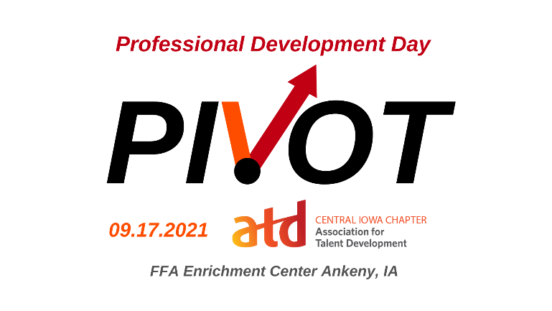
ATD Central Iowa Member Rate – $109.00 (USD)

Non-ATD Central Iowa Member – $189.00 (USD)

Student and Round Table Only - $39.00 (USD)

ATD Center Iowa Membership
Membership Renewal - $80.00 (USD) Subscription period: 1 year No recurring payments

New Membership - $85.00 (USD) Subscription period: 1 year No recurring payments First year ATD member

Student Membership - $25.00 (USD) Subscription period: 1 year No recurring payments

