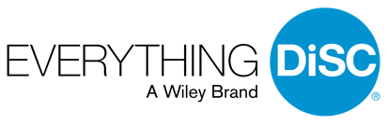
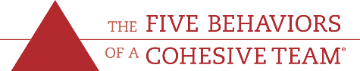

For Immediate Release
March 1, 2019

Contact Information:
Group Dynamic
1128 W. Jefferson
Winterset, IA 50273
Phone: 515.468.1969
Email: alan@groupdynamic.net

FOR IMMEDIATE RELEASE

Local Business Achieves Sales Honor

Minneapolis, MN—Wiley announced today that local business Group Dynamic is a 2018 Ruby Award winning Partner. The Ruby designation recognizes the Group Dynamic commitment to building better workplaces with the help of Everything DiSC® and The Five Behaviors of a Cohesive Team®, proven workplace assessment-driven solutions from Wiley.

“We are excited to partner with professionals like those at Group Dynamic who want to make a difference in the world of work,” says Susie Kukkonen, Vice President of Partner Channels at Wiley. “The Group Dynamic dedication to helping clients succeed, combined with their expertise in delivering Everything DiSC and The Five Behaviors are highly valuable to any organization. We are honored to have them as an Authorized Partner.”
About Group Dynamic
Alan Feirer is a leadership trainer, Authorized Wiley DiSC Partner, Five Behaviors of a Cohesive Team Authorized Partner, and organizational development consultant. For the last 18 years, he has done business as Group Dynamic, helping people solve problems and get more done by working with managers, directors, leadership teams, staffs, and team members to maximize the potential of their organization through leadership training, coaching, team-building and communications training.

About Everything DiSC® and The Five Behaviors of a Cohesive Team®
Everything DiSC is the leading suite of DiSC®-based workplace training and assessment solutions. These advanced applications combine online assessment, classroom facilitation, and post-training follow-up to create powerful, personalized workplace development experiences. With a global network of independent Partners, Everything DiSC solutions are used in thousands of organizations, including major government agencies and Fortune 500 companies.

The Five Behaviors of a Cohesive Team is an assessment-based program developed from the The New York Times best-selling book The Five Dysfunctions of Team by Patrick Lencioni. Designed exclusively for intact teams and work groups, the program helps members understand how they score on the key components of The Five Behaviors model: trust, conflict, commitment, accountability, and results.

###

